Implementing and using minitwit.

Flask’s github repository contains a cool example of a minitwitter. It is meant to be implemented in linux. The purpose of this post is to implement it in windows.

Steps:

- download the necessary tools
- effect changes to the config file
- recreate the database in sqlite
- run the app

Download the necessary tools
Go to https://git-scm.com/download/win and download the git bash client, install it and clone the project in your hard disk. For that purpose open the Git bash client and type the following commands:
cd c:\\
git clone https://github.com/pallets/flask
(For additional info about git and using it https://www.linkedin.com/pulse/api-test-automation-ci-using-github-jenkins-slack-talal-ibdah )
Once you do that, in your local disk navigate to C:\flask\examples\minitwit.
I copied the folder into my python’s folder:
C:\Python34\minitwit

Or simply click on “Clone or download” and hit “Download ZIP”
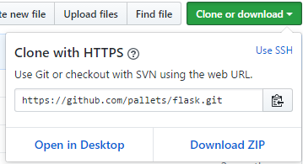
And proceed copying the folder minitwit to the python’s folder as indicated above.

Now install the needed flask libraries:
pip install flask
pip install flask-restful
pip install sqlalchemy

Note: in order to use pip you can download get-pip.py from https://pip.pypa.io/en/stable/installing/#do-i-need-to-install-pip, or use the file from this post. Then run python get-pip.py
Note: notice that pip is also a perl command so use the fully qualified path.

Install sqlite3.exe from https://sqlite.org/download.html, get the sqlite-tools-win32-x86-3180000.zip

Effect changes to the config file
I have modified the instructions in https://github.com/pallets/flask/blob/master/examples/minitwit/README

2.1 edit the configuration in the minitwit.py file: in my case C:\Python34\minitwit\minitwit\minitwit.py
The only change needed there is to convert from the original linus /tmp/minitwit.db to:
DATABASE = 'C:\\Python34\\minitwit\\minitwit\\tmp\\minitwit.db'
2.2 install the app from the root of the project directory

pip install --editable .

2.3. tell flask about the right application:

in this case change: export FLASK_APP=minitwit, change it to set FLASK_APP=minitwit

2.4. fire up a shell and run this:

Instead of flask initdb, I recreate manually the db:
    - with sqlite3.exe start a session in a cmd prompt. I started sqlite3.exe in the minitwit folder as shown below. Notice that .tables shows no tables.
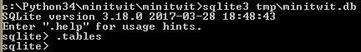
    - then I copied the contents of the schema.sql into sqlite. Now the tables have been created.

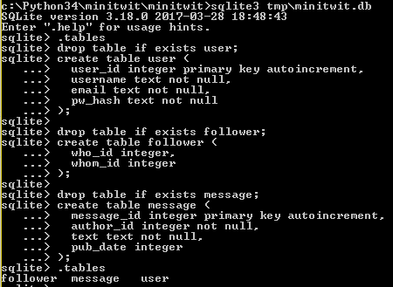

drop table if exists user;
create table user (
user_id integer primary key autoincrement,
username text not null,
email text not null,
pw_hash text not null
);

drop table if exists follower;
create table follower (
who_id integer,
whom_id integer
);

drop table if exists message;
create table message (
message_id integer primary key autoincrement,
author_id integer not null,
text text not null,
pub_date integer
);

5. now you can run minitwit:

Change flask run with
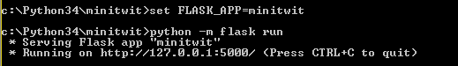
- in the browser, type localhost:5000, you are greeted with:
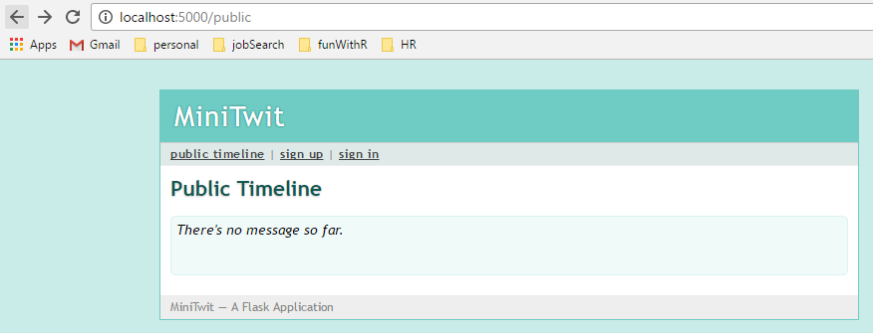
- at that point sign up and then sign in:

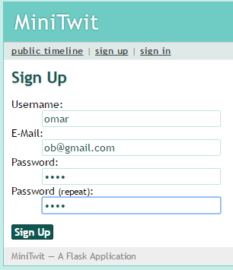
And start posting there:
